School Districts by PK-12 Enrollment – log scale

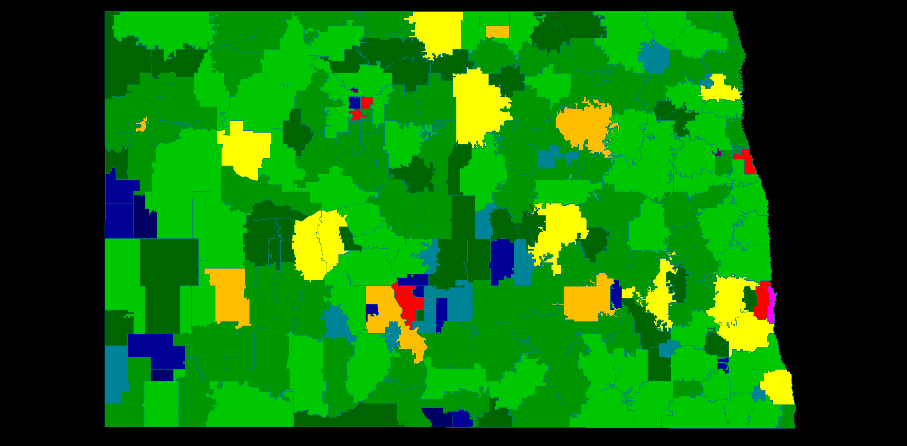

Chart of the Above



Percent pie chart of number of students for above



Census change 1991 to 1997

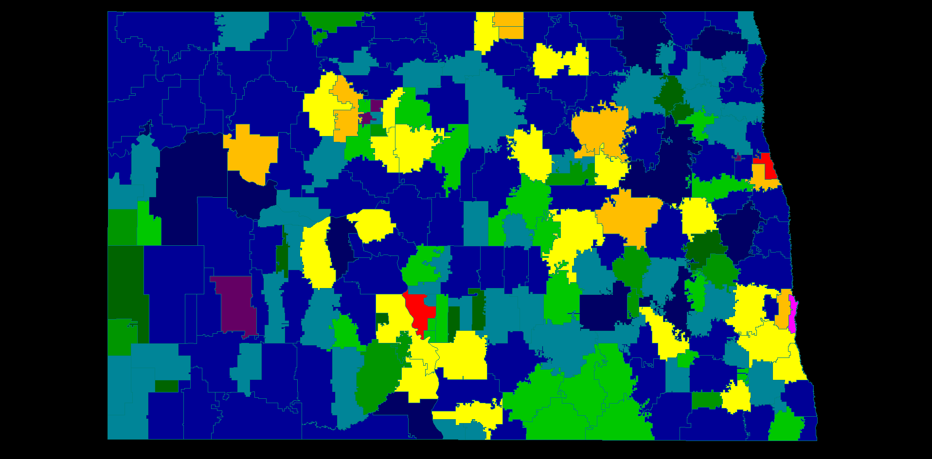

Percent change between 1991 and 1997

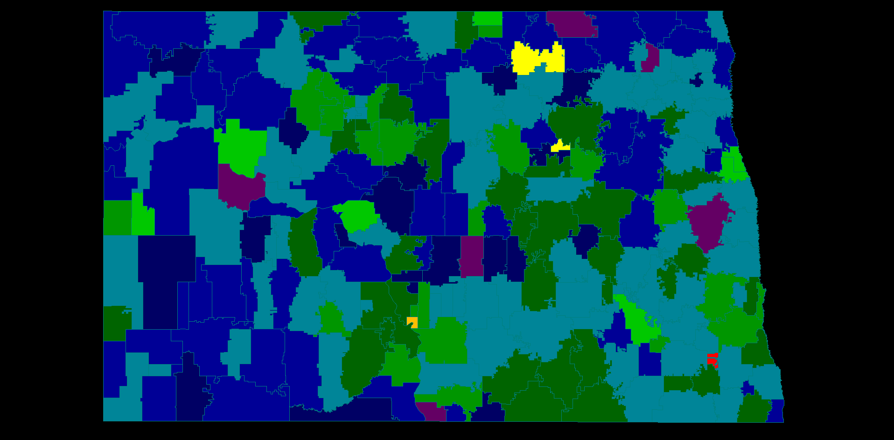

Small and Large HS districts

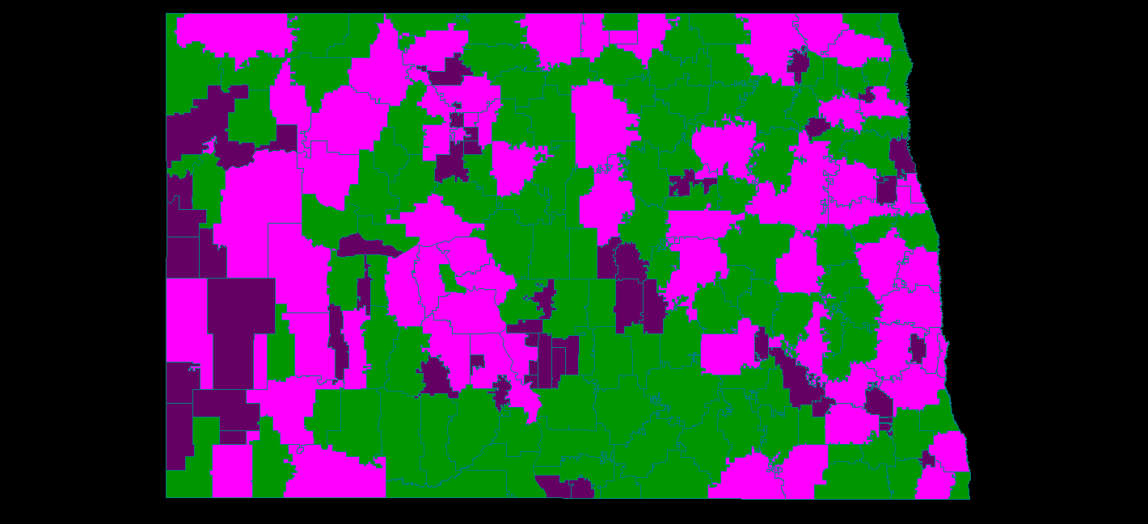

30 miles from Large HS

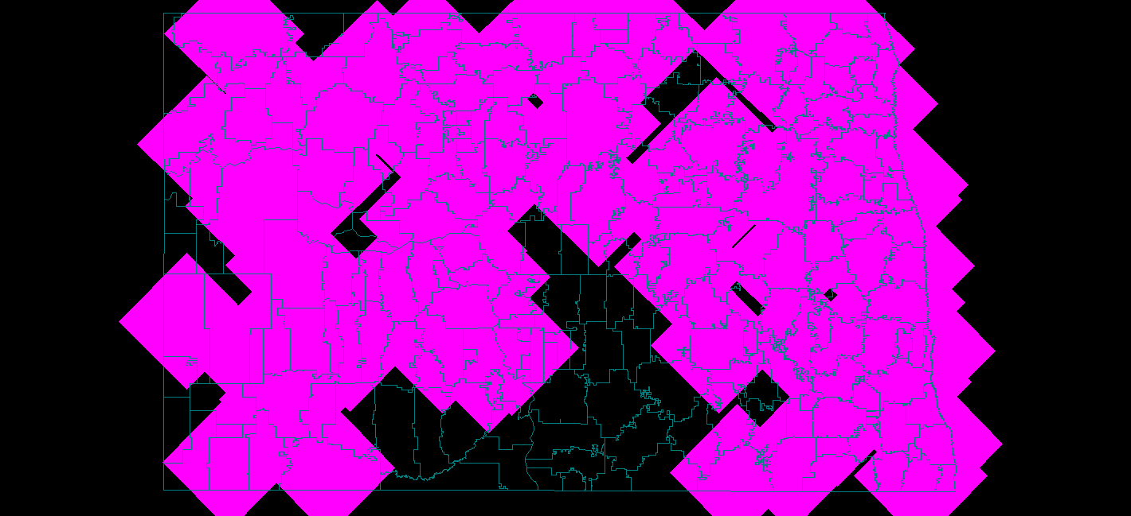

Facility location with 100 HS

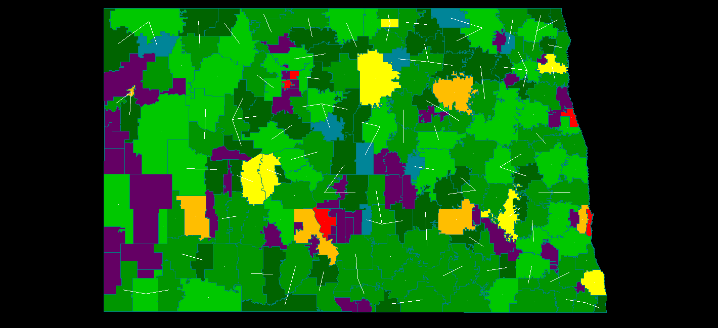

Facility location with 30 mile max distance

